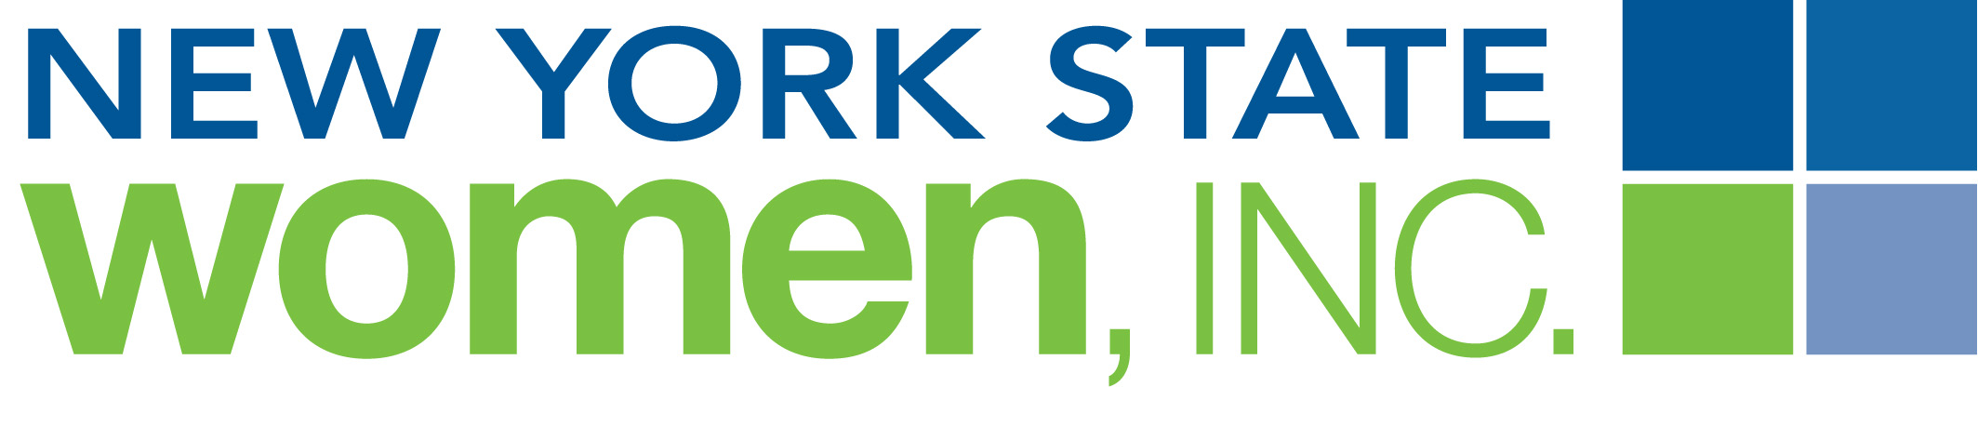
The New York State Women, Inc. Chapter’ Athena Society proudly presents a series of workshops to help military families transition from active duty to civilian life.

Hear about the Program Learn about the Workshops

Date (insert date)
Time (insert time)
Place (insert location)
For more information contact (insert name and contact information)

Workshop 1: Introduction
Goal: Getting to know you and what programs you want
Discussing your needs, what workshops you might be interest in and planning your program.

Workshop 2: Finances and budgeting
Goal: Spending money wisely
Creating a budget and other financial tools

Workshop 3: Home Basics
Goal: Creating a home in a civilian world
Helping to find a home, furnish a home, decorate home, finance a home and clean the home
Guide to Healthy Food and Shopping

Workshop 4: Resume building
Goal: to create a civilian resume based on their military experiences
Bring your DD214 and create a resume, using your skills, for civilian life

Workshop 5: Dress for Success
Goal: to get a job
Meet local businesses and explore clothes for the interview and work; hairstyles and other essentials.

Workshop 6: Helping with children
Goal: The Children see that their parents are there to help them
Sharing household chores and other responsibilities of both parents and children

